Chapter

**Snake Game**

**AIM:**

The aim of the Snake Game is to control a snake to collect food items scattered around the game area. Each time the snake eats a food item, it grows longer. The game continues until the snake collides with itself or the boundaries of the game area.

* **Collect Food:** Guide the snake to eat as many food items as possible.
* **Avoid Collisions:** Prevent the snake from colliding with the walls or its own body.
* **Grow the Snake:** The more food the snake eats, the longer it becomes, making the game progressively more challenging.

**Introduction:**

The Snake Game introduces players to a simple yet engaging challenge where they control the movements of a snake on a screen. The game mechanics are straightforward: maneuverer the snake towards food items represented as dots or other symbols. Each time the snake consumes a piece of food, it grows longer. As the snake grows, manoeuvrings become more challenging because the player must avoid collisions with the snake's own body and the boundaries of the game area.

The game's appeal lies in its simplicity and addictive nature. Players aim to achieve high scores by skillfully navigating the snake to eat as much food as possible without crashing. Over time, variations of the Snake Game have emerged, incorporating different graphics, levels of difficulty, and additional features such as obstacles or multiplayer modes.

**Procedure:**

* Open PyCharm IDE software.
* Go to Menu —> File —> New Project.

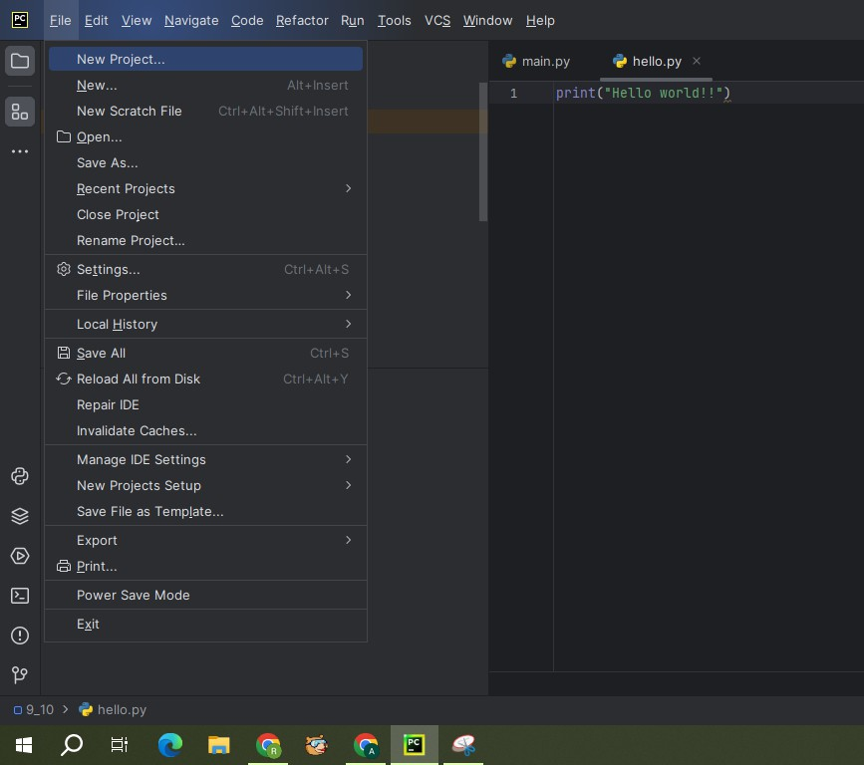

* 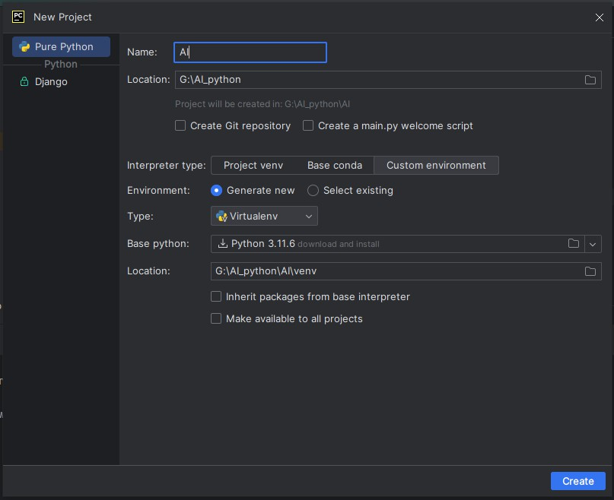A window will be appeared as below. Change the Name and Location of the project as per our requirement. Select custom environment for interpreter type. Select Generate new for Environment. Select Virtualenv for Type. Select latest version of python for Base python i.e., Python 3.11.6. And click on create
* Once our project is created, right click on project. Go to —> New —> Python File.

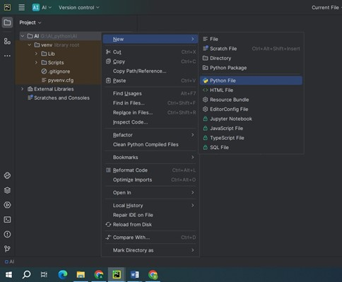

* Give the name to the python file: SnakeMain.py.

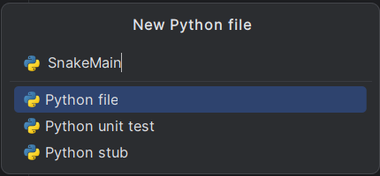

* Once the file is created, copy below given code to SnakeMain.

**SnakeMain code:**

from SnakeGameClass import *

import cv2

from cvzone.HandTrackingModule import HandDetector

cap = cv2.VideoCapture(0)

cap.set(3, 1280) # set the frame width

cap.set(4, 1024) # set the frame height

detector = HandDetector(detectionCon=0.8, maxHands=1)

game = SnakeGameClass("donut.png")

while True:

success, img = cap.read()

img = cv2.flip(img, 1)

hands, img = detector.findHands(img, flipType=False)

if not game.gameOver: # Check if game is not over

if hands: # if at least one hand is detected

lmList = hands[0]["lmList"]

pointIndex = lmList[8][0:2]

img = game.update(img, pointIndex) # update the score and the snake length

else:

cvzone.putTextRect(img, "Game Over. Press 'r' to restart.", [300, 400], scale=3, thickness=3, offset=20)

if cv2.waitKey(1) == ord('r'): # Restart game if 'r' key is pressed

game.gameOver = False

game.score = 0

cv2.imshow("img", img)

key = cv2.waitKey(1) # store the pressed key

if key == ord('q'):

break

cv2.destroyAllWindows()

cap.release()

**Libraries to install:**

Ensure you have the following libraries installed before running the code:

Go to Menu —> View —> Tool Windows —> Terminal.

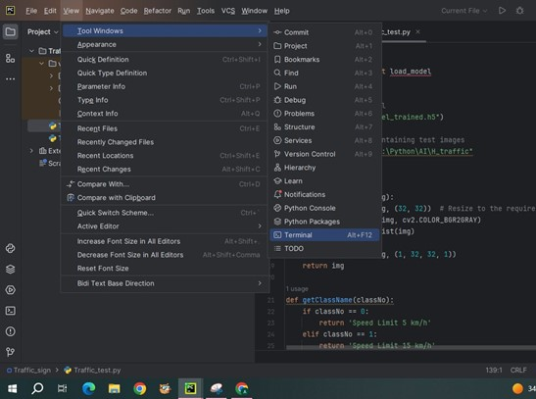

* **Open-cv:**

This command will install the main OpenCV package for Python, which includes the core functionalities for computer vision applications. If you need additional modules or specific versions, you can specify them accordingly.Install Pygame library, type the below command in terminal:

pip install opencv-python

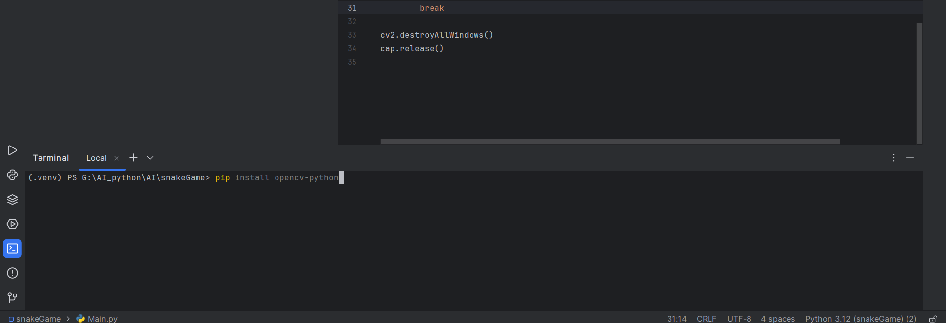

* **CV Zone:**

CVZone is a Python library that extends OpenCV functionalities, providing various utilities and features for computer vision applications. It's particularly known for its ease of use and additional functionalities beyond OpenCV's core capabilities. To install CVZone, you can use pip:

pip install cvzone

* **NumPy:**  
   NumPy is a powerful Python library used for numerical computing. It provides support for large, multi-dimensional arrays and matrices, along with a collection of mathematical functions to operate on these arrays efficiently. Here are some key features and functionalities of NumPy:

pip install numpy

* Once our project is created, right click on project. Go to —> New —> Python File.



* Give the name to the python file: SnakeGameClass.py.

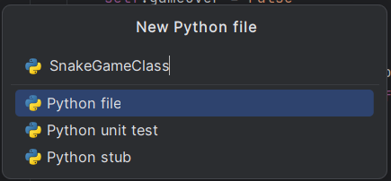

* Once the file is created, copy below given code to balloon pop game.

**SnakeGameClass code:**

import math

import cv2

import random

import cvzone

import numpy as np

class SnakeGameClass:

def __init__(self, pathFood):

self.initializeData()

self.gameOver = False

self.score = 0

# interactging with the food

self.imgFood = cv2.imread(pathFood, cv2.IMREAD_UNCHANGED)

self.hFood, self.wFood, _ = self.imgFood.shape # get deminsions size image

def randomLocation(self):

self.foodPoint = random.randint(100, 300), random.randint(100, 300)

def initializeData(self):

self.points = [] # all points of snake

self.lenghts = [] # distances between each point

self.currentLength = 0 # total lenght of the snake

self.allowedLength = 150

self.previousHead = 0, 0

self.foodPoint = 0, 0

self.randomLocation()

def update(self, imgMain, currentHead):

if self.gameOver:

cvzone.putTextRect(imgMain, "Game Over", [300 // 2, 400 // 2], scale=3, thickness=3,

offset=20)

cvzone.putTextRect(imgMain, f'Your Score {self.score}', [300 // 2, 550 // 2], scale=3, thickness=3,

offset=20)

else:

cx, cy = currentHead

px, py = self.previousHead

self.points.append((cx, cy))

distance = math.hypot(cx - px, cy - py)

self.lenghts.append(distance)

self.currentLength += distance

self.previousHead = cx, cy

# length reduction

self.reduceLength()

# check if the snake ate the food

rx, ry = self.foodPoint

if (rx - self.wFood // 2 < cx < rx + self.wFood // 2 and ry - self.hFood // 2

< cy < ry + self.hFood // 2):

self.score += 1

self.allowedLength += 50

self.randomLocation()

# draw snake

if (self.points):

for i, point in enumerate(self.points):

if i != 0:

cv2.line(imgMain, self.points[i - 1], self.points[i], (0, 0, 255), 15)

cv2.circle(imgMain, self.points[-1], 15, (200, 0, 200), cv2.FILLED)

# draw dount

cvzone.putTextRect(imgMain, f'Score {self.score}', [50, 80], scale=3, thickness=2,

offset=10)

imgMain = cvzone.overlayPNG(imgMain, self.imgFood, (rx - self.wFood // 2, ry - self.hFood // 2))

# check for collision

pts = np.array(self.points[:-2], np.int32)

pts = pts.reshape((-1, 1, 2))

cv2.polylines(imgMain, [pts], False, (0, 200, 0), 2)

distace = cv2.pointPolygonTest(pts, (cx, cy), True)

if (-1 <= distace <= 1):

self.gameOver = True

self.initializeData()

return imgMain

def reduceLength(self):

if (self.currentLength > self.allowedLength):

for i, lenght in enumerate(self.lenghts):

# i keep reducing form the length snake until reach the allowed length

self.currentLength -= lenght

self.lenghts.pop(i)

self.points.pop(i)

if (self.currentLength < self.allowedLength):

break

**Running:**

* Run the SnakeMain code

**Output:**

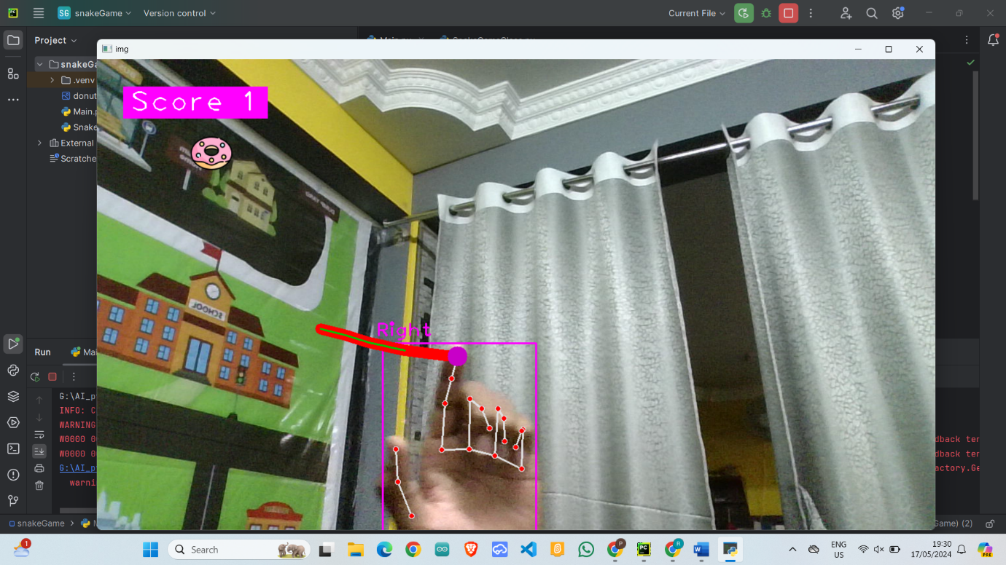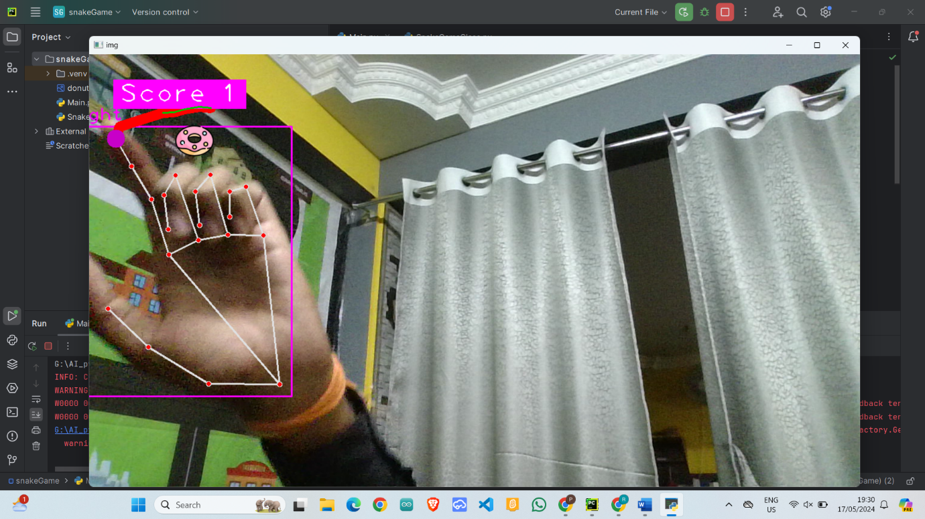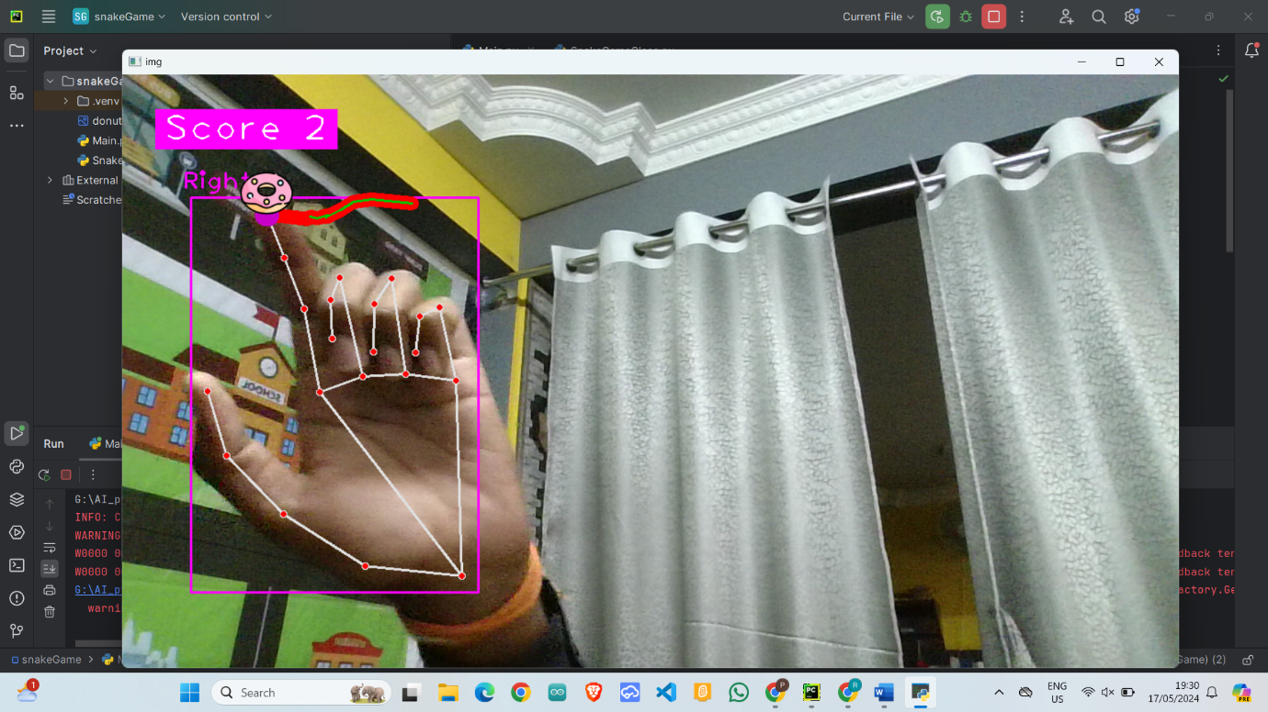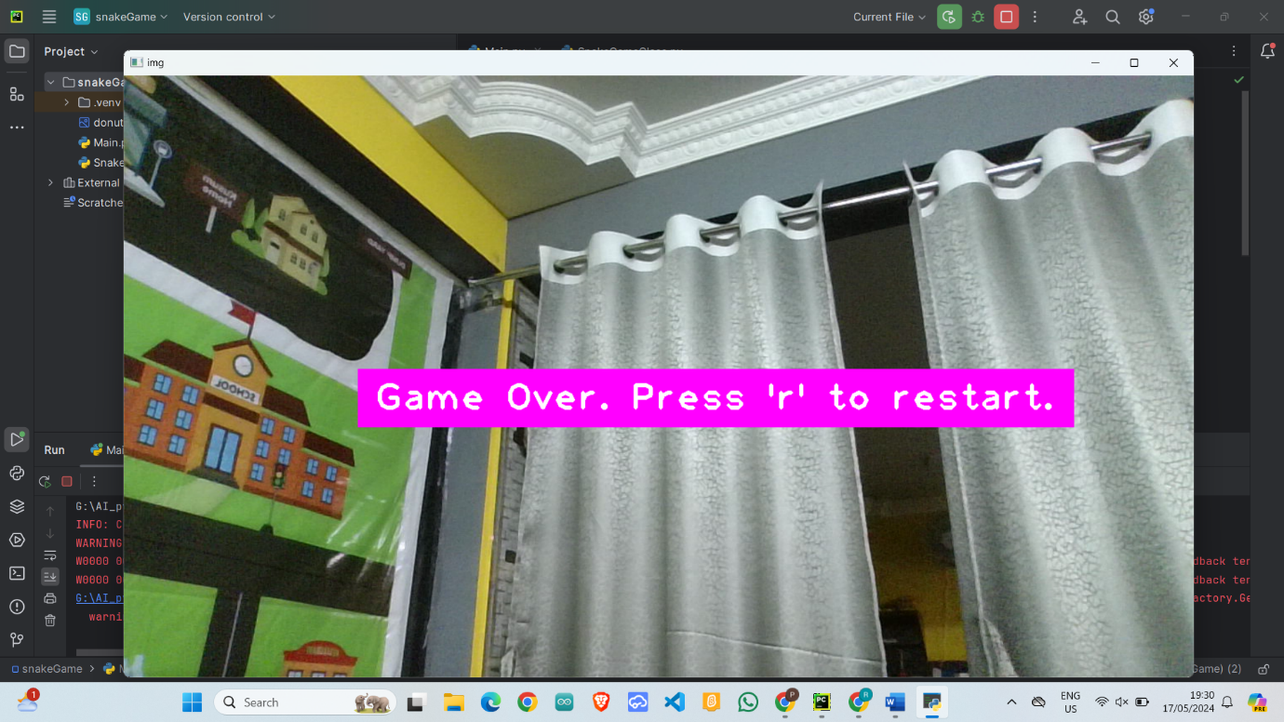

**Conclusion:**

Snake Game often reflects the player's skill in maneuvering the snake efficiently to gather food while avoiding collisions. It's a straightforward yet challenging game that encourages quick thinking and spatial awareness.

Modern versions of the Snake Game may also include additional features such as different levels of difficulty, graphical enhancements, or alternative game modes, which can influence the overall conclusion and player experience.